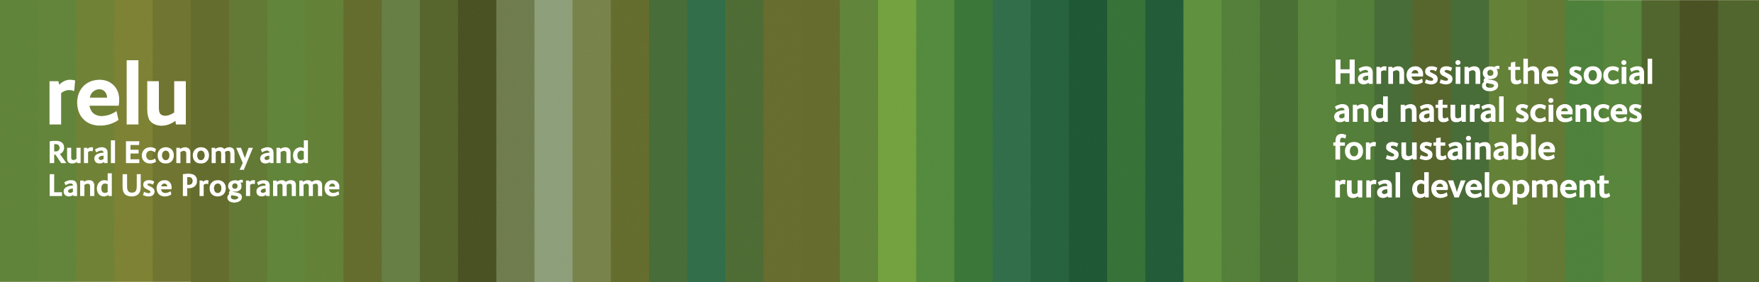
1 June 2009

PRESS RELEASE for immediate release

How healthy is your river?

How do you know how healthy your local river is, and whether it is improving? Academics at the universities of East Anglia and London think they have come up with the answer – a simple report card, like the one a schoolchild brings home at the end of the school year.

The project team will be demonstrating the effectiveness of the report card at the Rural Economy and Land Use “The Future of Rural Land Use” Conference at Congress House, Great Russell Street, London on Thursday 4 June 2009. Members of the press are welcome to attend the conference.

Water companies and environmental regulators are gathering a mass of data from monitoring the physical, chemical and biological quality of the surface water and groundwater in catchments. But it is difficult for the non-expert to make sense of all this information, and how it relates to water consumer and citizen concerns about water quality, fishing, wildlife and the recreational use of rivers. The report card draws this information together with simple graphics to indicate the overall ecological health of the river system.

The researchers have developed the report card, using the River Thurne in Norfolk and the River Tamar in the south west as their case study areas. The original idea was sparked off by a scheme that has been used to protect Moreton Bay in Queensland, Australia. But this new version is tailored to the issues faced by river managers in the UK and the team is confident that it could be applied across other catchments.

Kevin Hiscock, University of East Anglia, who researched the report card, said: “The report card, with its colour coding, is an effective way to communicate the health and cleanliness of our waterways and makes it easy to understand the issues and priorities at a glance. Also, the annual compilation and publication of the report card enables the success or otherwise of decisions determining the allocation of resources to improve the ecosystem health of a river to be evaluated.”

The card is just one element in a project designed to develop guidance on improving water quality and to identify the governance arrangements that would be necessary to achieve this. The research is part of the UK Research Councils’ Rural Economy and Land Use Programme.

Laurence Smith, SOAS, University of London, who is leading the research, said:
“The project aims to provide guidance for policy and practice and the ecosystem health report card is just one tool that authorities could use. By communicating water quality and changes in water quality effectively, we will raise awareness among landowners, residents and visitors about the state of catchments, how this improves or deteriorates over time, and the factors that influence such changes. In turn, improved awareness can support action for improvement.”

Notes for editors
- For more information about the ecosystem health report card and illustrations see http://www.relu.ac.uk/news/policy%20and%20practice%20notes/Smith%20PP7%20final.pdf

- For information about the Future of Rural Land Use conference see http://www.relu.ac.uk/events/Conf%20June%202009/11064%20RELU%20A5%20Conf%20Invite%20Amended.pdf

- The Rural Economy and Land Use Programme is a multi-disciplinary collaboration between the Economic and Social Research Council (ESRC), the Biotechnology and Biological Sciences Research Council (BBSRC) and the Natural Environment Research Council (NERC), with additional funding provided by the Scottish Government and the Department for Environment, Food and Rural Affairs. See www.relu.ac.uk for more information about the Relu programme.
- For information about UEA see http://www.uea.ac.uk/ or contact Simon Dunford tel 01603 592203 email s.dunford@uea.ac.uk
- For information about SOAS see www.soas.ac.uk or contact Mary O’Shea tel 020 7898 4075 email mo2@soas.ac.uk.
- For any further information contact Relu Science Communications Manager Anne Liddon, tel 0191 2226880 email anne.liddon@ncl.ac.uk.
ends

